

Data Mining

“Exploring the US real estate market in King County”

Monday Group, Students:

Alessandro Boldorini 240207

Mathurin Gamichon 240762

Shahad,Muhammad Ali 243409

Academic year: 2017/2018

Table of Contents

Data Description 3

Outliers 4

K-Nearest Neighbour 6

K means 8

Decision tree 14

Conclusion 20

# Data Description

The dataset for this project we have selected it’s from Kaggle ( https://www.kaggle.com/bala7123/king-county/data ) and the data is about King County ‘s (US) homes sold between May 2014 and May 2015. Below it is shown a presentation of the data set. For each house, we have a unique Identification Number, the Price on the market and some information, in particular:

* Dimension in square feet, number of bedrooms, bathrooms and floors;
* The year of construction;
* Waterfront, so if the house is built in front a source of water;
* The condition of the house (1 for the worst condition, 5 for the best);
* Zipcode, which identify the city in which the house is built.

In the last two columns of the table we can see an example of how we grouped the houses for year of construction and for dimension, in order to make some analysis easier. In particular:

* Year_built interval is [1;10], and we grouped our houses in intervals of 10 years each;
* For sqft_living interval is [1;51], and we grouped our houses in intervals of 260 sqft (so approximately 25 square meters).

The total number of observation is 21613.

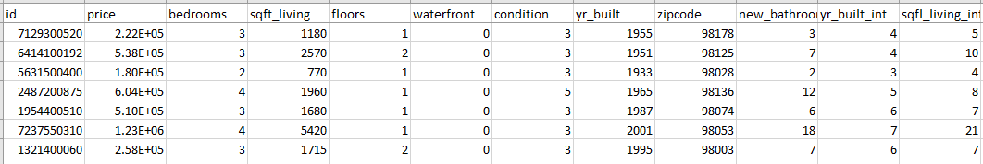

Below we show some basic statistic about our dataset:

|  |  |  |  |  |  |
| --- | --- | --- | --- | --- | --- |
|  | | | | | |
|  | N | Range | Minimum | Maximum | Mean |
| Statistic | Statistic | Statistic | Statistic | Statistic |
| price | 21613 | 7,625 E+006 | 7,5 E+004 | 7,7 E+006 | 5,4009 E+005 |
| bedrooms | 21613 | 33 | 0 | 33 | 3,37 |
| bathrooms | 21613 | 58,00 | ,00 | 58,00 | 3,1148 |
| sqft_living | 21613 | 13250 | 290 | 13540 | 2079,90 |
| floors | 21613 | 2,5 | 1,0 | 3,5 | 1,494 |
| waterfront | 21613 | 1 | 0 | 1 | ,01 |
| condition | 21613 | 4 | 1 | 5 | 3,41 |
| yr_built | 21613 | 115 | 1900 | 2015 | 1971,01 |
| zipcode | 21613 | 198 | 98001 | 98199 | 98077,94 |
| Valid N (listwise) | 21613 |  |  |  |  |

# Outliers

After the basic analysis, we tried to find the outliers of every independent variable by the dependent variable (price).

We realized that there are so much outliers. This is probably because our data set is huge, more than 21 thousand houses but also because the house market isn’t standardized. For example, there are some extra big houses or “little castles” which can’t really be compared with a “normal” house. Also, we think that the most expensive houses (which are just a few number of observation) are automatically considered ad outliers, because of the high price.

We provide two examples of boxplots, showing this problem about the outliers:

**Independent variable: yr_build.**

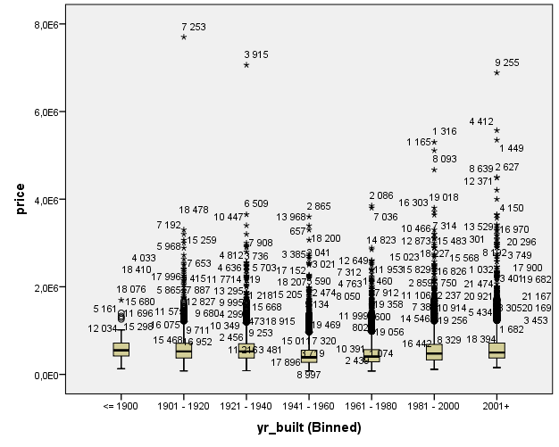

**Independent variable new_bathrooms:**

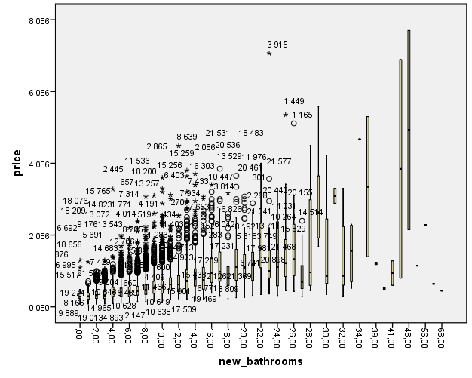

As we can see there is a lot of outliers in absolute value but considering the percentage on the total number of observation it remains decent.

We can also note that there are only above price outliers and not below. So, we can say that the outliers are only too expensive houses and not too cheap houses.

For the variable *new_bathrooms* some number are only for one house (41,56...) so it can’t show outlier for these values.

For every other variable, the outlier graphic is similar to the two above.

We tried to find the most important outliers, that means the houses which are considered outlier in every variable. We find these 6 outliers:

Considering the mean ($ 540.008 $) and standard deviation ($ 367.127) of the price we can see that those houses are very expensive compared to the dataset.

# K-Nearest Neighbour

We applied the KNN algorithm to our data in order to make a prediction about the price of a house we choose. The process was subdivided in 3 parts:

* Analyse the data we have in order to find the best K based on our factors and dataset;
* Forecast prices of all the houses using KNN method, calculate the average mean absolute error;
* Forecast the price the house we choose.

First of all, we ran the algorithm introducing some intervals in order to understand which values of the K were the most interesting. We started by introducing:

* [2;5];
* [6;10];

We saw that the most interesting values of K was around the middle of the interval [4,5,6,7], so we decided to run another time the algorithm with only these 4 values. We found that K=6 was the best result.

After that we tried to run the algorithm considering normalisation and weight of the factors. The aim of this analysis was to discover the minimum SSE and which factors were the most important to consider for the forecast. The results were:

|  |  |  |  |  |
| --- | --- | --- | --- | --- |
| K | Normalisation | Weighted | Feature List | SSE |
| K = 6 | Y | N | sqft_living zipcode waterfront bedrooms bathrooms floors | 5,39E+14 |
|
|
|
|
|
| Y | Y | sqft_living zipcode waterfront bathrooms bedrooms | 5,29E+14 |
|
|
|
|
| N | Y | sqft_living zipcode waterfront | 5,93E+14 |
|
|
| N | N | sqft_living zipcode waterfornt floors | 5,20E+14 |
|
|
|

Discovered that, we proceeded in calculate the errors of our prediction.

|  |  |
| --- | --- |
| SSE | 2,43661E+32 |
| % variation abs | 18,7% |

As we can see the prediction error is within an interval between [10%;20%] so we can say that KNN is a quite suitable algorithm for prediction.

After we tried to predict the price of a house. We found another house and we considered just the most important factors of KNN initial analysis. We applied the algorithm and the result we found is:

|  |  |  |  |  |  |
| --- | --- | --- | --- | --- | --- |
| Real Price | Predicted Price | Sqft_living | Zipcode | Waterfront | Floors |
| 6,70E+05 | 7,24E+05 | 2820 | 98034 | NO | 2 |

We calculate the percentage mean absolute error also for the forecasting:

|  |  |
| --- | --- |
| % average absolute error | 8,06% |

The error of the prediction is good.

# K means

Before the implementation of the algorithm, we decided to apply a ***Factor Analysis***, to find new components that could explain better our dataset. With the *factor analysis*, we found 9 new factors.

In the table below we can see our results, the Total variance, % of Variance and Cumulative.

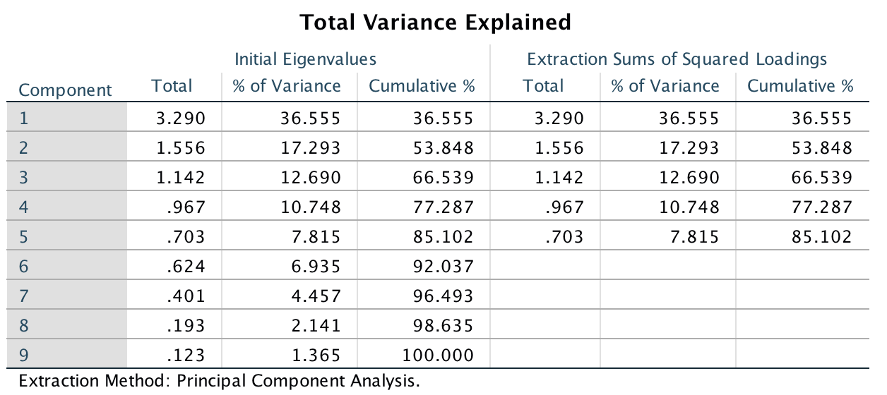



Considering the result we obtained, we decided to adopt as new factors for the K-means analysis just the first 3 component. This because:

* they explain approximately the 70% of the variance;
* The eigenvalue of this components is over 1, while the other factors have an eigenvalue under 1.

Below we can see the component matrix. We highlight the most important factors correlated to our components.

**Component Matrix**

|  |  |  |  |
| --- | --- | --- | --- |
|  | 1 | 2 | 3 |
| price | .665 | .411 | .322 |
| bedrooms | .720 | .266 | -.349 |
| floors | .563 | -.444 | .283 |
| waterfront | .126 | .290 | .695 |
| condition | -.178 | .666 | -.332 |
| zipcode | -.303 | .251 | .469 |
| new_bathrooms | .910 | .128 | -.153 |
| yr_built (Binned) | .515 | -.686 | -.006 |
| sqft_living (Binned) | .883 | .204 | .017 |

Considering these new components, we can say that:

* Component 1, is more correlated with *bedrooms*, *bathrooms* and the dimension of the house (*sqft_living*). So, a higher value of this factor will mean that a particular house is big and with a high number of bathrooms and bedrooms.
* Component 2, is correlated with condition and *year_built*, so new houses in good conditions.
* Component 3 in correlated with *waterfront*, so if the house is in front a river, lake, seaside. We can also assume that *zipcode* is quite correlated to this factor.

The second step of the implementation of the K-means algorithm, was trying to find the best value for the K. To do this, because our dataset is quite large (more than 21000 observation), we applied the *2Step Cluster Analysis*.

The best result we had was K=6. Considering the *silhouette analysis*, as we can see in the picture below, the quality of our model is not “good”, but we decided to use this K because in the observations we had by running the algorithm a few times, this was the best result.

In the table below we can have more insight about the cluster of the 2Step Cluster Analysis.

|  |  |  |  |  |
| --- | --- | --- | --- | --- |
| **Cluster** | **percent(values)** | **percent(values)** | **V4** | **V5** |
| 1 | 0.819 | 177 | 1 | 0.818951 |
| 2 | 13.3253 | 2,880 | 2 | 13.325313 |
| 3 | 18.4657 | 3,991 | 3 | 18.465738 |
| 4 | 27.2197 | 5,883 | 4 | 27.219728 |
| 5 | 22.3292 | 4,826 | 5 | 22.329153 |
| 6 | 17.8411 | 3,856 | 6 | 17.841114 |

After these first two initial steps, we run the K-Means algorithm, using the new factors found through the factor analysis, and using the K of the 2step Cluster analysis. Below we can see some results taken from SPSS output of the algorithm.

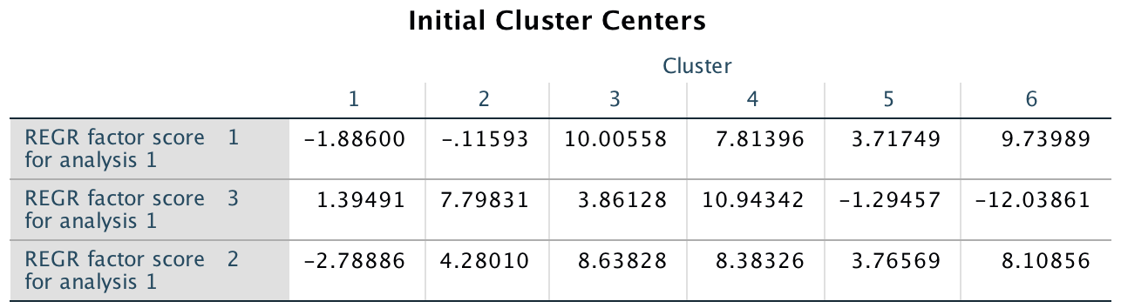

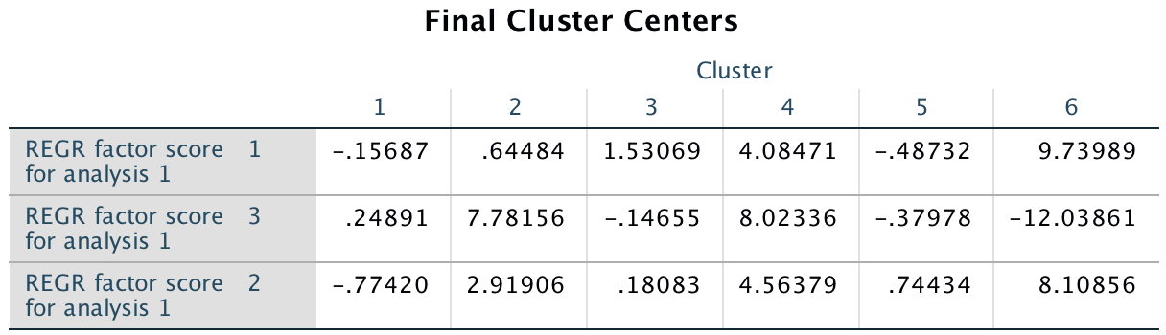

To better understand how a cluster works we give now some examples of description of these clusters, considering the components we had in the 1st step (Factor analysis, Component Matrix table). In particular:

* Cluster 4 and Cluster 6, compared to the other, have the highest value for the first factor. So, we can say that these clusters contain big houses, with a huge amount of bathroom bedrooms.
* Cluster 2, Cluster 4 and Cluster 6 have the highest value of factor 2. So, considering the component of factor 2, these clusters contain the newer houses in good conditions.

For each cluster, the number of observations is shown in the table be

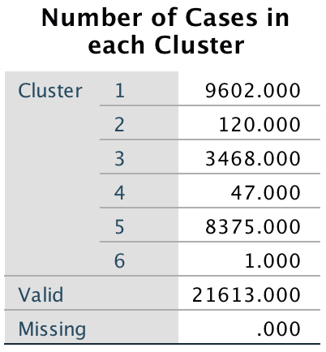

Cluster 1 is the one with the most number observations.

Cluster 6 instead, has just one observation. We found this result quite interesting, so we deepened our analysis about this. In particular, for Cluster 6 the observation is the n° 15871. In the tables below we present in detail the characteristic of this observation and the values for each factors.

|  |  |  |  |  |  |  |  |  |
| --- | --- | --- | --- | --- | --- | --- | --- | --- |
| Price | Bedroom | Sqft_liv | Floors | Waterfront | Condition | Year | Zipcode | Bathrooms |
| 6.4E+005 | 33 | 1620 (group n°7) | 1.0 | 0 | 5 | 1947  (group n° 4) | 98103 | 58.00 |

|  |  |  |
| --- | --- | --- |
| Factor 1 | Factor 2 | Factor 3 |
| 9.73989 | 8.10856 | -12.0386 |

This house has the highest number of Bedrooms and Bathrooms, and is in the best condition on the market (we remember that 5 is the maximum grade). We think that those are the reason than stand behind the fact this is the only observation of cluster 6.

Considering the Anova table, looking to the column ”significance”, because we don’t have over the 5%, we can say that our factors explain very well the model.

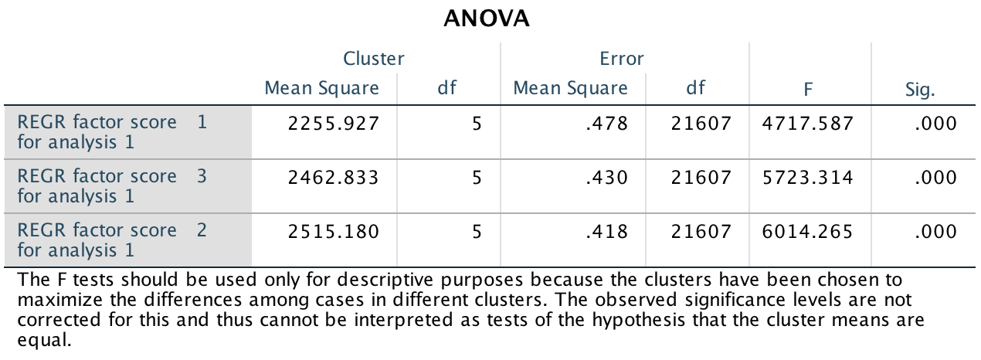

We calculate also the criterion function of our results. Because the value is quite high, we can say that our results are good.



In conclusion of our algorithm implementation we tried to forecast the price of the house we choose for the KNN analysis. We know that the K-means is not a forecasting algorithm. We obtained this result:

|  |  |  |  |  |  |  |
| --- | --- | --- | --- | --- | --- | --- |
| Price | Cluster 2, avg price | Sqft_living | Zipcode | Waterfront | Floors | % error |
| 6,70E+05 | 6,55E+04 | 2820 | 98034 | 0 | 2 | -42% |

The house is part of cluster number 2. For the prediction, we considered as “predicted price” the average price of the houses contained in cluster number 2. As we can see the % error in high, as we can expect from an algorithm not fitted for forecasting.

# Decision tree

We tried to predict the house price with a Decision tree models. We tested 3 different tree models, CHAID, Exhaustive CHAID and CRT.

|  |  |  |
| --- | --- | --- |
| Specifications | Growing Method | EXHAUSTIVE CHAID |
| Dependent Variable | price |
| Independent Variables | bedrooms, floors, condition, waterfront, zipcode, sqft_living, new_bathrooms, yr_built |
| Validation | None |
| Maximum Tree Depth | 3 |
| Minimum Cases in Parent Node | 1000 |
| Minimum Cases in Child Node | 500 |
| Results | Independent Variables Included | sqft_living, zipcode, new_bathrooms |
| Number of Nodes | 29 |
| Number of Terminal Nodes | 22 |
| Depth | 3 |

**Exhaustive Chaid method:**

The global error is:

|  |  |
| --- | --- |
| **Risk** | |
| Estimate | Std. Error |
| 73847794327,194 | 3839862011,159 |
| Growing Method: EXHAUSTIVE CHAID  Dependent Variable: price | |

**CRT method:**

|  |  |  |
| --- | --- | --- |
| Specifications | Growing Method | CRT |
| Dependent Variable | price |
| Independent Variables | bedrooms, floors, waterfront, condition, zipcode, sqft_living, yr_built, new_bathrooms |
| Validation | None |
| Maximum Tree Depth | 5 |
| Minimum Cases in Parent Node | 1000 |
| Minimum Cases in Child Node | 500 |
| Results | Independent Variables Included | sqft_living, new_bathrooms, bedrooms, yr_built, waterfront, zipcode, floors, condition |
| Number of Nodes | 17 |
| Number of Terminal Nodes | 9 |
| Depth | 5 |

The global error is:

|  |  |
| --- | --- |
| **Risk** | |
| Estimate | Std. Error |
| 74557922610,014 | 3880769490,488 |
| Growing Method: CRT  Dependent Variable: price | |

As example, below is shown the CRT tree:

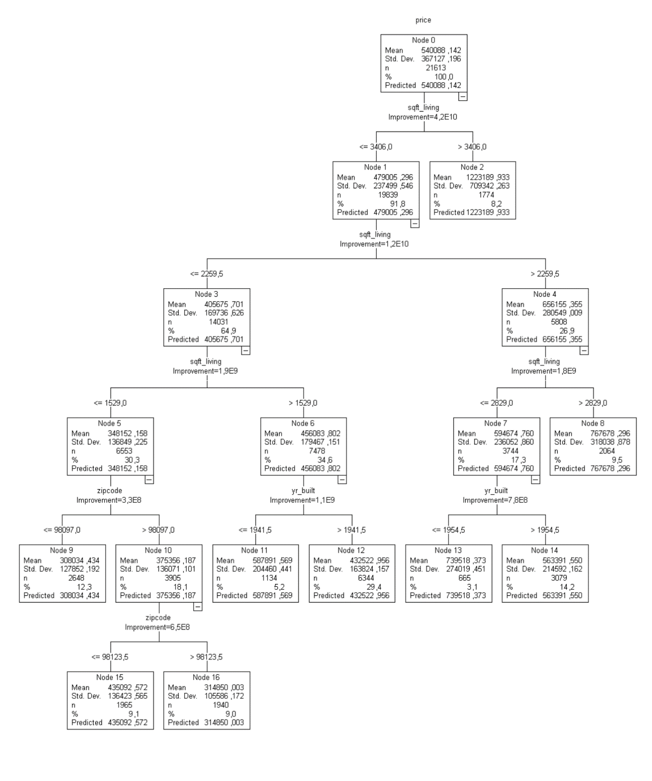

**Chaid method**

|  |  |  |
| --- | --- | --- |
| Specifications | Growing Method | CHAID |
| Dependent Variable | price |
| Independent Variables | bedrooms, floors, condition, waterfront, zipcode, sqft_living, new_bathrooms, yr_built |
| Validation | None |
| Maximum Tree Depth | 3 |
| Minimum Cases in Parent Node | 1000 |
| Minimum Cases in Child Node | 500 |
| Results | Independent Variables Included | sqft_living, zipcode, yr_built, condition, new_bathrooms, bedrooms |
| Number of Nodes | 46 |
| Number of Terminal Nodes | 29 |
| Depth | 3 |

The global error is:

|  |  |
| --- | --- |
| **Risk** | |
| Estimate | Std. Error |
| 73099843676,453 | 3780791491,745 |
| Growing Method: CHAID  Dependent Variable: price | |

Chaid method tree is the model with the smallest error.

So, we used this tree to deepen our analysis. Below is showed the tree:

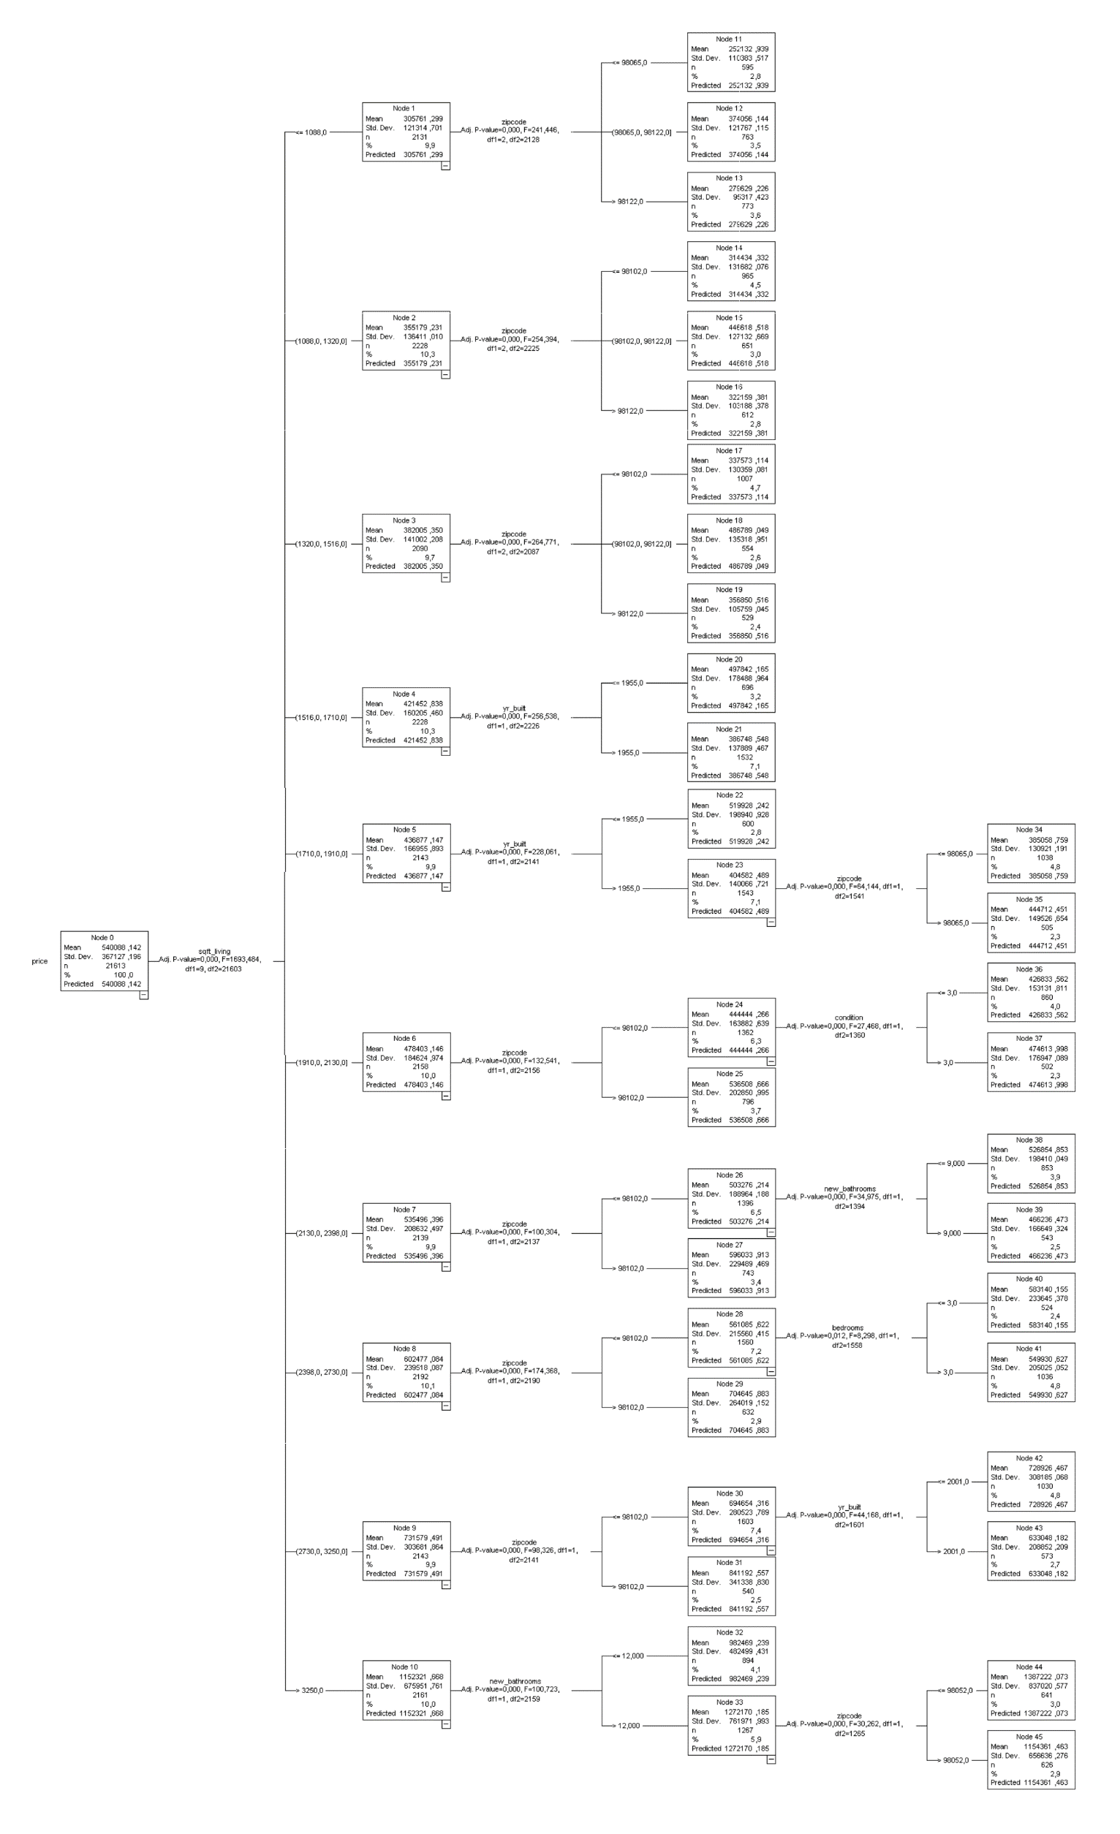

1

8

7

6

5

4

3

2

The decision tree works in this way (description from top to bottom, numbers of the list correlated with numbers of the picture in the previous page):

* First it checks the *sqft_living* value and divides the data set into 10 nodes:
  1. For the first 3 leaf, it checks the *zipcode* value and divides it in 9 final nodes.
  2. For the 4th leaf it checks *year_build* and divides it in 2 final nodes.
  3. For the 5th leaf it checks again *year_build* value and then divides it in 2 nodes, one is a final, and the other it checks the *zipcode* and divides it in 2 final nodes.
  4. For the 6th leaf it checks the *zipcode* value, then divides the tree in 2 nodes, one is a final, and the other it checks the *new_bathroom* and divides it in 2 final nodes.
  5. For the 7th leaf it checks the *zipcode* value, then divides it in 2 nodes, one is a final, and for the other it checks *new_bathroom* and divides it in 2 final nodes.
  6. For the 8th leaf it checks *zipcode* value then divide it in 2 nodes, one is a final, and for the other it checks the *bedrooms* and divides it in 2 final nodes.
  7. For the 9th leaf it checks *zipcode* value, then divides it in 2 nodes, one is a final, and for the other it checks the *year_built* and divides it in 2 final nodes.
  8. For the 10th leaf it checks *new_bathroom* value then divides it in 2 nodes, one is a final, and for the other it checks *zipcode* and divides it in 2 final nodes.

We also predicted the price of our house with this decision tree model.

|  |  |  |  |  |  |  |
| --- | --- | --- | --- | --- | --- | --- |
| Real price | sqft living | yr build | Node | Zipcode | Predicted Price | % abs error |
| 6,70E+05 | 2820 | 1960 | 42 | 98034 | 7,29E+05 | 8,80% |

We calculate the error between the predicted price and the real one:

|  |  |
| --- | --- |
| % mean absolute error | % mean absolute error (prediction) |
| 33,2% | 15,91% |

The error is quite huge, the algorithm is not suitable to our dataset to predict.

# Conclusion

After the application of all the algorithms we calculate the absolute mean percentage error between:

* the real prices of the houses, provided by the dataset;
* the predicted prices we had from the application of the algorithm.

The results are the following:

|  |  |  |
| --- | --- | --- |
| Method | % mean absolute error | % mean error in prediction |
| KNN | 18,7% | 8,06% |
| Decision Tree (CHAID) | 33,20% | 15,91% |
| K-means | 39,37% | 41,74% |

* As expected the worst error is with the K-means algorithm. This because K-means is not an algorithm for prediction. In particular, we used the average price calculated per cluster for the prediction, and this led to a high value of the error.
* The Decision Tree developed with CHAID methodology gave also us a high value of the error. As for the K-means, also in Decision Tree the prediction is based on average prices calculated for every leaf (sub-level) of the tree.
* The K-nearest Neighbour (KNN) provide us the best result in terms of % error. Because the error is in an interval between [10%;20%] we can say that KNN is a quite suitable algorithm for our dataset.

Considering our dataset and the factors we worked with, we obtained those results in terms of importance of factors in each algorithm:

|  |  |
| --- | --- |
| Method | Factors |
| K-neighbours | sqft_living zipcode waterfornt floors |
|
|
|
| Decision Tree (CHAID) | sqft_living zipcode bathrooms year_built condition |
|
|
|
|
| K-means | sqft_living  waterfront condition bathrooms  bedrooms |
|
|
|
|

As we can see from the table (the factors are ranked based on their importance, from top to bottom), we have some common factors and not:

* *Sqft_living* is the factors that all the 3 algorithms take into consideration, so we can say that the dimension of a house is the first factor that all the algorithms correlate to the price;
* Comparing the KNN with the other 2 algorithms we can see that they both take into account different factors:
* Both the other two algorithms are based on a higher number of factors;
* Both have just two of the same important factors of KNN.
* We can assume that this difference lead to a higher error: probably in both algorithms the use of a higher number of factors lead the prediction to be affected by some disturbance made from a factor that is not very important considering the final economy of the prediction.
* Comparing also DT and K-means we can see that they consider 2 different factors (zipcode - year built / waterfront - bedrooms).

|  |  |  |  |  |
| --- | --- | --- | --- | --- |
|  |  |  | Factors | Method |
|  | |  | | --- | |  | |  | sqft_living (*) zipcode bathrooms (*) year_built condition (*) | Decision Tree (CHAID) |
|  |  |  |
| Method | Important Factors |  |
| KNN | sqft_living zipcode waterfornt floors |  |
|  |
|  | sqft_living (*) waterfront condition (*) bathrooms (*) bedrooms | K-means |
|  |
|  |  |  |
|  |  |  |
|  |  |  |

We thought also about another reason that led our algorithms to have those “high” errors. In fact, considering all our factors and the outlier analysis, for each of them we have lots of outliers. We take as example the box plot we did for the *Sqft_living*.

For a better visualisation of the data we organised the houses into intervals of dimension.

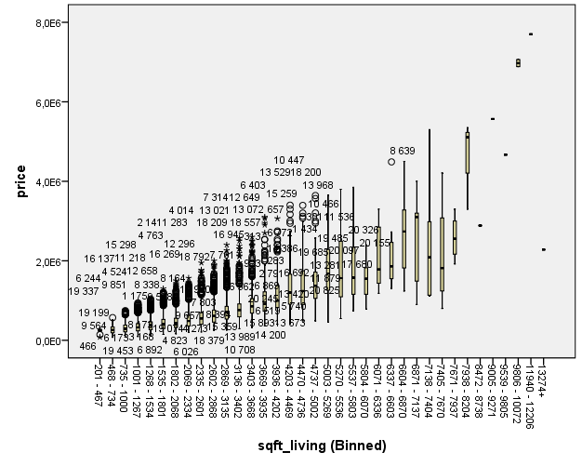

As we can see from the picture, also splitting our data into intervals the number of outliers is high, and we think that this “dirtiness” of our data can affect the results.

For improve the prediction we taught about two strategies:

* Clean the dataset from points that are outliers for more than 3 factors (considering we have 9 factors, it’s 1/3 of the total);
* Split the data set into two parts. In particular considering the *sqft_living,* we can split the dataset into “Little flat” and “Big flat”. We think that this kind of split can lead to a higher homogeneity of data, so maybe we can obtain better results by running all the algorithms for the 2 new groups, little and big.